## How UX Can Boost Your Business Potential

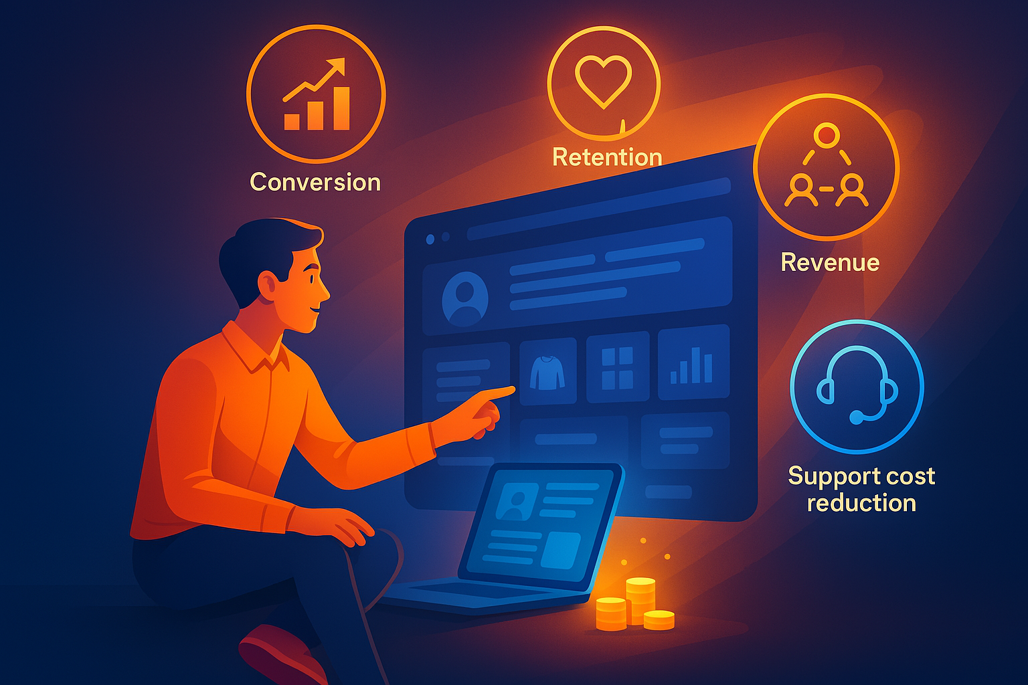

Can good UX design actually drive business success? Absolutely. The connection between well-crafted user experiences and increased revenue is undeniable, and in today’s digital age, businesses can no longer afford to overlook the power of UX. When users enjoy seamless, intuitive interactions with a product or service, they’re more likely to return, engage more deeply, and ultimately spend more.

But how exactly does UX translate into real business outcomes? Let’s dive deeper into how user experience design can fuel growth, from increasing customer retention to boosting revenue through personalization, and why businesses that invest in UX are more likely to thrive in competitive markets.

## Personalization: Turning Insights into Conversions

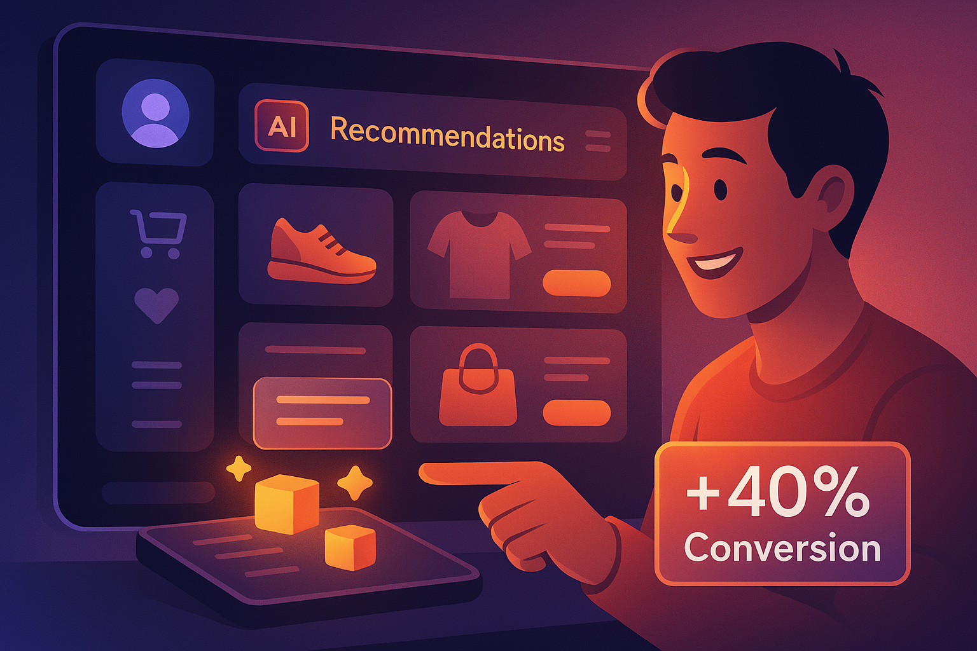

Personalization has become one of the most powerful tools in a business’s UX arsenal. Customers today expect tailored experiences—recommendations that speak directly to their preferences, personalized messaging, and even tailored product offerings. This is particularly relevant in eCommerce, where personalized shopping experiences can lead to a significant increase in conversion rates and overall revenue.

For example, let’s say a user frequently browses sportswear on an eCommerce site. Through effective UX design, the website can recognize this pattern and present them with a personalized selection of products, special discounts on sportswear, or even notifications when items they’ve viewed go on sale. This kind of personalization not only makes the user’s journey more efficient and enjoyable, but it also drives a deeper emotional connection with the brand. According to studies, personalization in eCommerce can lead to up to a 40% increase in conversion rates.

But personalization isn’t just for eCommerce. In industries like banking, healthcare, or SaaS, a personalized user experience can mean the difference between retaining customers and losing them to competitors. When users feel understood and catered to, they’re more likely to stick around—and that loyalty translates into repeat business and long-term revenue growth.

## Reducing Churn: Designing for Satisfaction

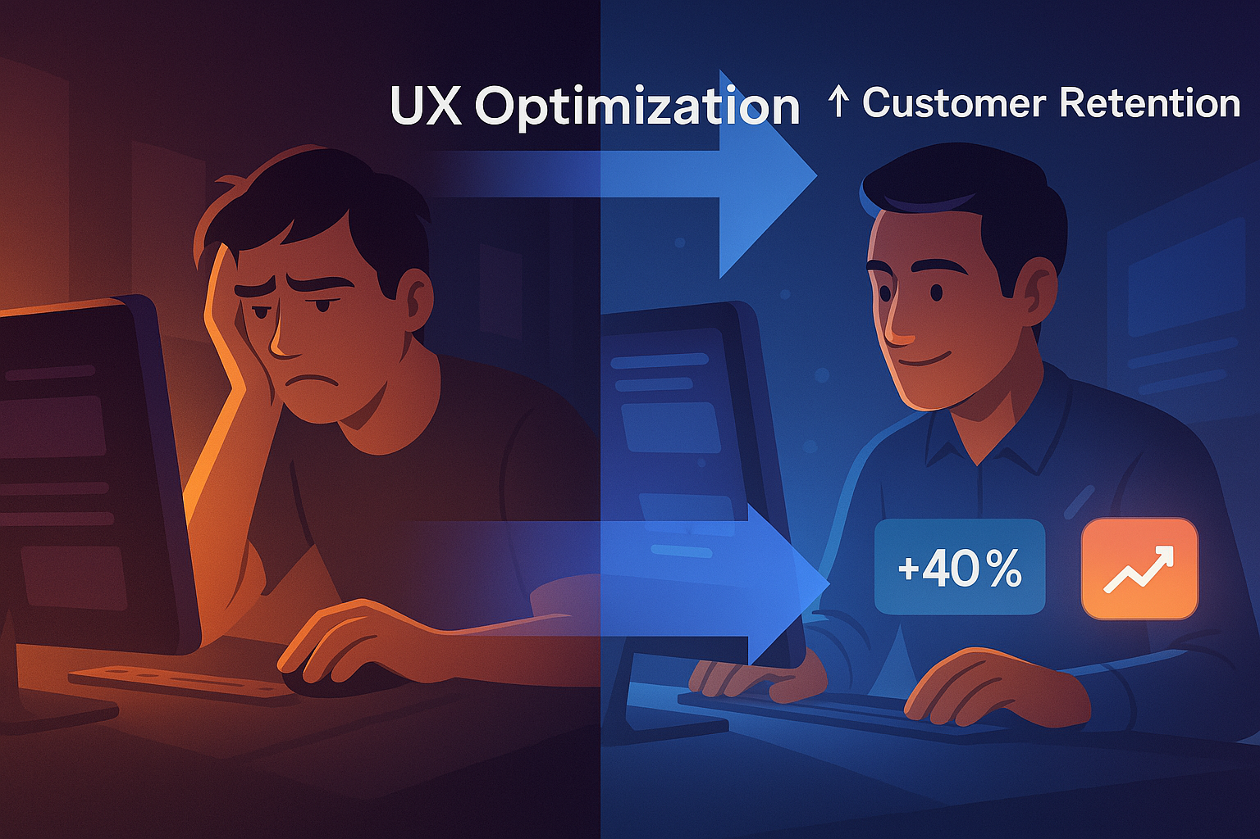

Churn is the enemy of sustainable business growth. If users find your product frustrating, hard to navigate, or unclear in its value proposition, they’re unlikely to return. This is where UX design shines. By identifying pain points in the user journey—whether through user testing, feedback, or data analysis—you can optimize your product to meet user needs, reduce friction, and create a more enjoyable experience.

For instance, simplifying complex workflows or reducing the number of steps in a conversion funnel can have an immediate impact on reducing churn. Consider a SaaS platform where users need to complete a multi-step setup process to start using the software. If that process is cumbersome or unintuitive, users may give up before they even begin. By redesigning the onboarding experience to be more streamlined and user-friendly, businesses can significantly reduce drop-off rates and improve customer retention.

Lower churn rates have a direct impact on revenue. Not only does retaining customers cost far less than acquiring new ones, but satisfied customers are also more likely to refer others, create positive word of mouth, and engage in higher-value transactions over time.

## Lowering Support Costs: Empowering Users through Intuitive Design

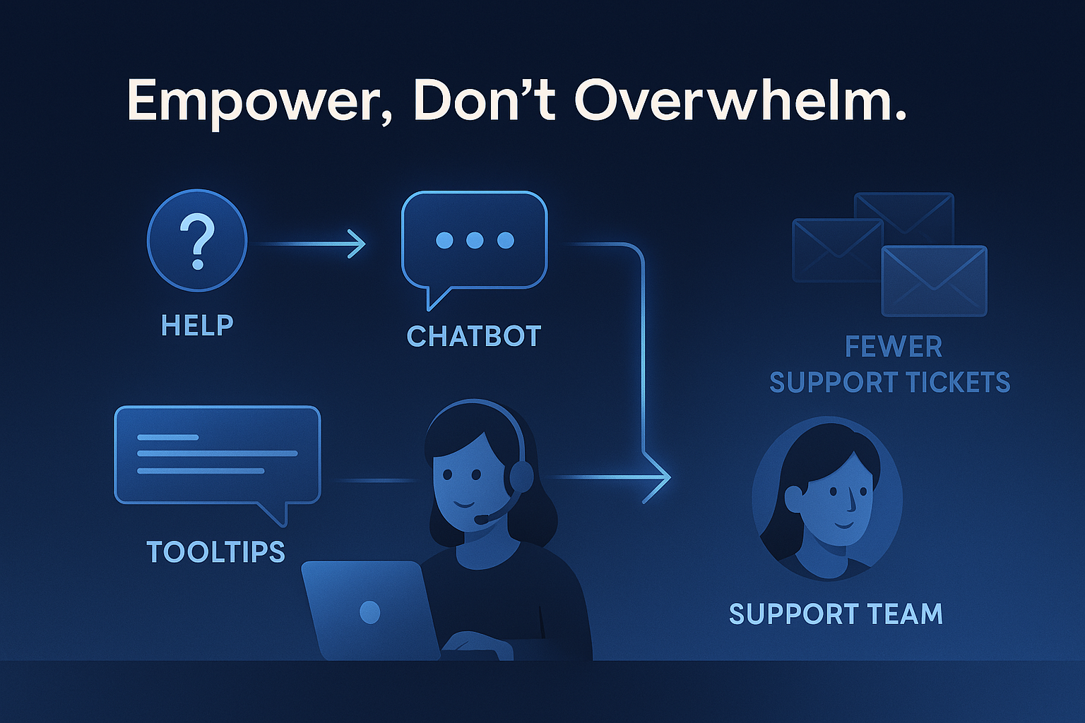

Another often overlooked benefit of good UX design is the potential to lower support costs. When users can easily navigate your product or service without confusion, they’re less likely to reach out for help. This means fewer support tickets, less time spent on troubleshooting, and reduced demand for customer service resources.

Let’s consider a complex enterprise software platform. If the UX design is clear, with easily accessible help guides, tooltips, and intuitive navigation, users will be empowered to find solutions to their own issues without needing to contact support. In contrast, poorly designed products can lead to frustrated users who rely heavily on support staff to complete even basic tasks. Over time, this strain on resources can erode profit margins.

By investing in user-friendly designs, businesses can reduce their support burden, freeing up resources to focus on growth initiatives. This not only saves money but also enhances the overall user experience, as customers will associate the product with ease and efficiency rather than frustration and delays.

## UX as a Growth Driver: Aligning User and Business Goals

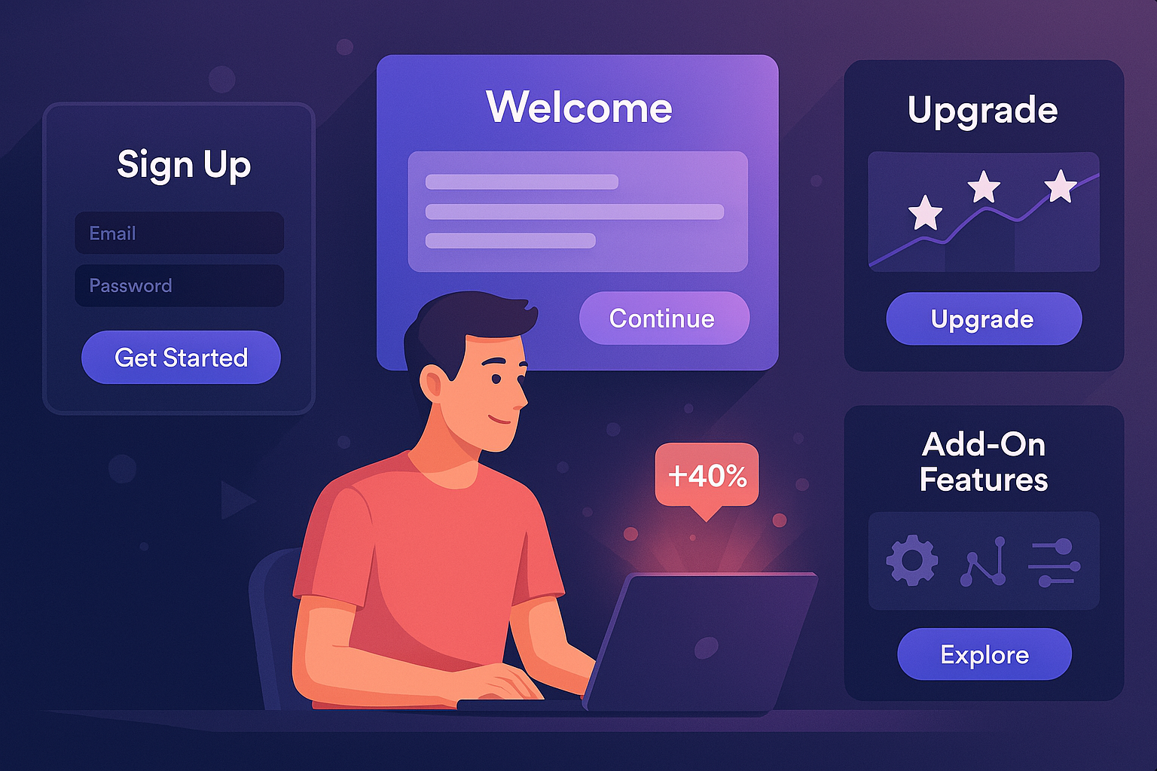

At its core, designing with business potential in mind means understanding not only the user’s needs but also the commercial goals of the business. It’s about finding the intersection between what users want and what the business needs to thrive. Whether it’s through simplified onboarding processes, streamlined navigation, or a thoughtful layout, UX has the power to turn users into loyal customers, directly impacting a company’s bottom line.

Take onboarding as an example. First impressions matter, and a smooth, well-designed onboarding process can set the tone for the entire customer relationship. If a user can quickly and easily get started with your product, they’re more likely to continue using it and eventually become a paying customer. A clunky or confusing onboarding experience, on the other hand, can lead to early abandonment, lost revenue, and a damaged brand reputation.

Similarly, thoughtful UX design can lead to increased cross-selling and upselling opportunities. When users can easily navigate through additional features or premium options, they’re more likely to make upgrades or additional purchases. This applies to industries ranging from eCommerce to SaaS platforms, where a seamless experience can lead to users discovering new products or services they didn’t initially consider.

## The ROI of UX: Why It Pays to Invest

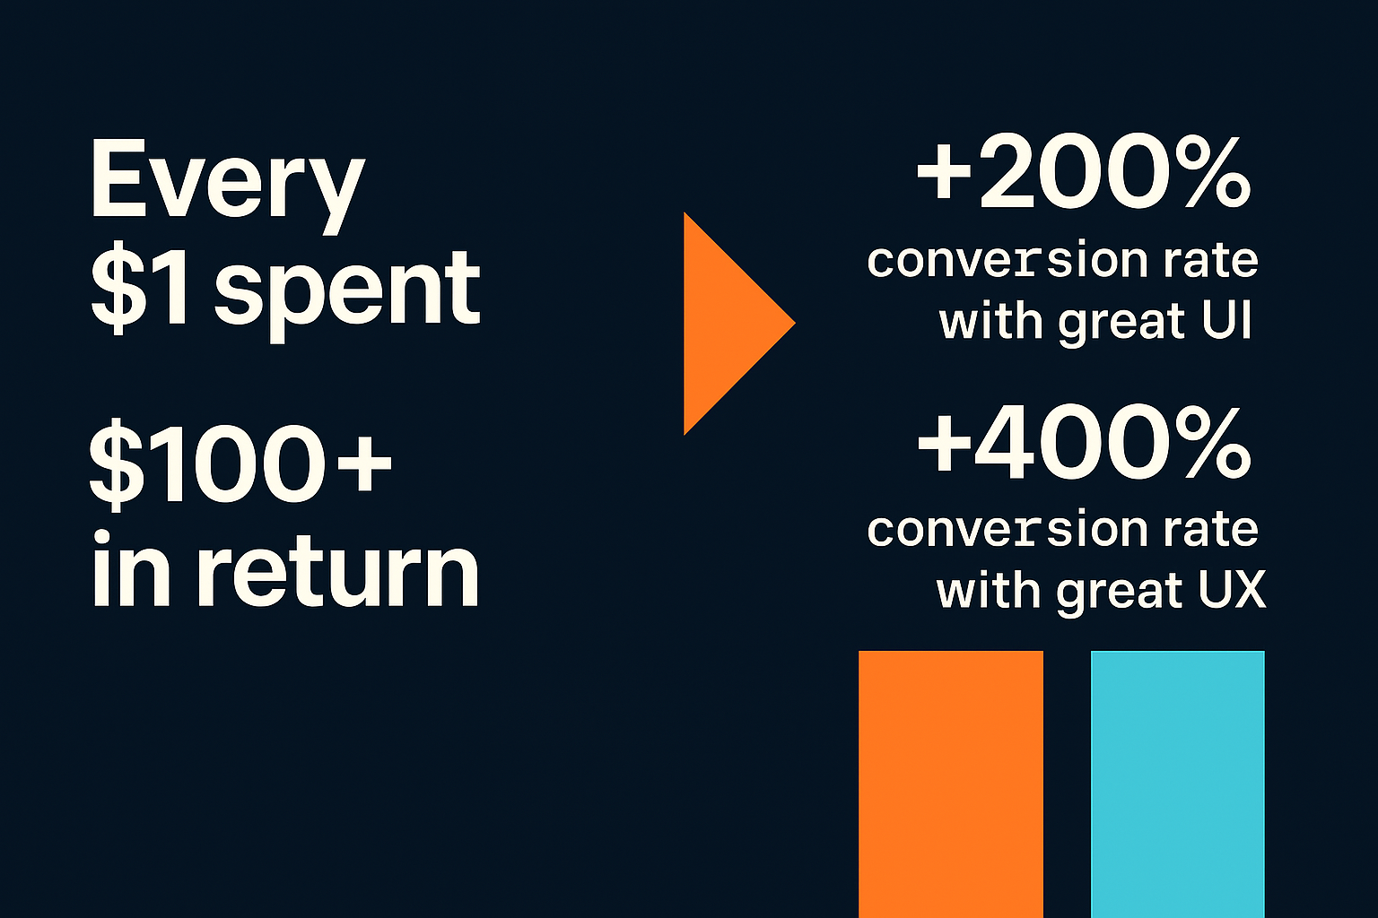

Investing in UX design is more than just an aesthetic decision—it’s a strategic business move with a high return on investment. Numerous studies have shown that every dollar invested in UX can yield returns of $100 or more in terms of improved conversion rates, customer satisfaction, and reduced support costs. This makes UX one of the most cost-effective areas for driving business growth.

Furthermore, companies that prioritize UX tend to outperform their competitors in terms of both customer retention and revenue growth. According to Forrester, a well-designed user interface could raise your website’s conversion rate by up to 200%, and a well-executed UX could yield conversion rates of up to 400%. The numbers speak for themselves: businesses that invest in UX are more likely to succeed in today’s competitive landscape.

## Conclusion: Designing for Success

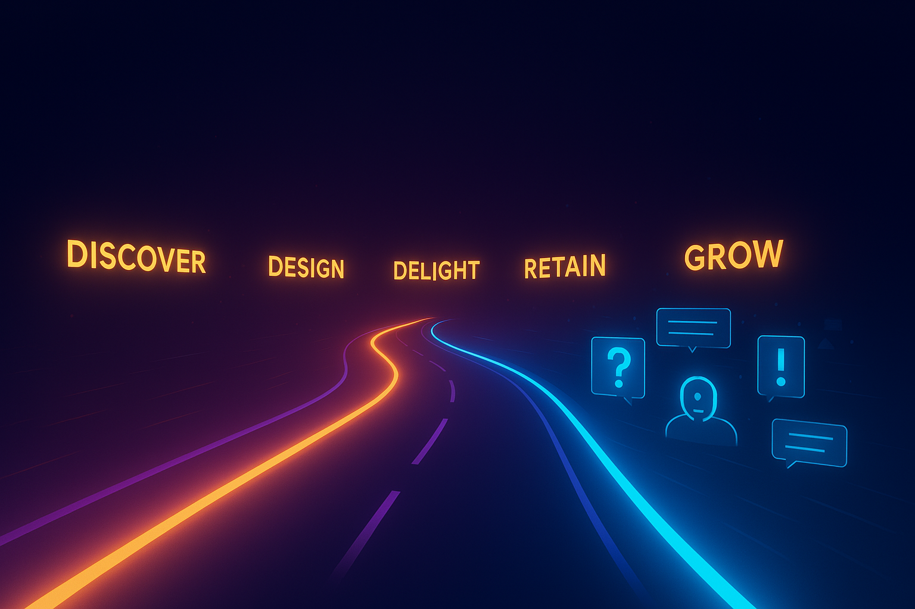

In today’s digital-first world, businesses cannot afford to overlook the impact of UX on their bottom line. By creating seamless, enjoyable experiences that cater to user needs, businesses can drive higher engagement, reduce churn, and boost revenue. From personalized eCommerce experiences to simplifying complex workflows, UX design is the key to turning casual users into loyal customers.

So, the next time you’re considering how to grow your business, remember: investing in UX isn’t just about creating a product that looks good—it’s about creating a product that works for your users and drives long-term success.